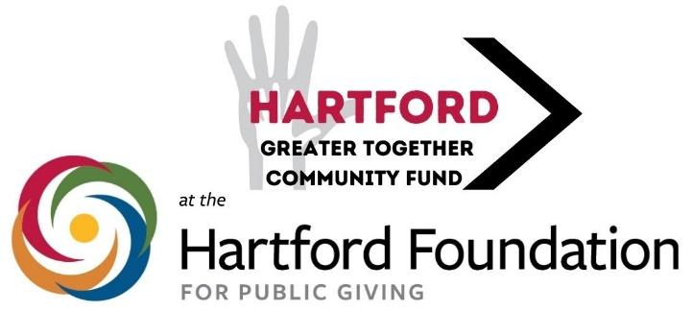

For Immediate Release

Media Contact: David Barrett - Committee Member

[dsbarrett@aol.com](mailto:dsbarrett@aol.com), 860-539-7275

**Hartford Greater Together Community Fund Announces New Awardees**

Hartford, CT (January 6, 2025) - The Hartford Greater Together Community Fund at the Hartford Foundation for Public Giving has awarded 2024 grants to 11 community organizations to address critical needs of city residents.

Grants ranged from $2,500 to $4,000 and totaled $33,580.

Overall, since 2021, the Fund has awarded 44 grants totaling $120,730 to address a wide range of community needs.

“In 2024, we received the highest number of applications for any grant cycle, which indicated to us the importance of the fund as a resource for nonprofits to help them carry out their work for Hartford’s various communities,” said Lara Langer, Chair of the Fund’s Committee that distributes the grants. “We are proud to support these organizations providing essential services in a range of fields, including health and wellness, education, food insecurity, career development and the arts, and we are thrilled to be able to contribute to their efforts.”

The Greater Together Community Fund, established by the Hartford Foundation in 2019, is directed by a committee of Hartford residents from various backgrounds and city neighborhoods. It supports residents in taking ownership around the needs of their city through grantmaking.

The Community Fund aims to support local nonprofits that are serving Hartford residents to address education, wellness, mental health, housing security, food security, childcare, health care, job readiness, literacy, and other critical issues.

To be eligible for a grant, an organization must have an annual operating budget of $1 million or less and its project has to serve primarily Hartford residents.

2024 awardees are:

* **Hartford Catholic Worker**, $4,000, to assist with food, rent payments, utilities, clothes, and funeral expenses for residents in North Hartford in need of these core necessities.
* **Just Be Big**, $4,000, to support a “Big Beautiful Wellness Retreat” that will provide a holistic experience that empowers plus-size women by focusing on mental, physical and emotional well-being.
* **Theta Alpha Sigma Alumnae Chapter of Sigma Gamma Rho Sorority,** $3,500, to host a community baby shower for roughly 50 expectant mothers, primarily Hartford residents. The event offers essential supplies and education geared toward improving pregnancy outcomes in high-risk communities.
* **Aknew.org**, $3,500, to support their program, Life Skills 2025. Funds will be used for a series of cooking and sewing classes for children and adults - six cooking classes, eight sewing classes, 10 families a week for each class.
* **Invent the Summer**, $3,080, to support Hartford Community STEM Workshops. Eight STEM workshops will be held in summer 2025 for Hartford children 5 to 12 years old.
* **Night Fall**, $3,000, to provide community workshops with Night Fall artists. Night Fall will stage six hands-on workshops for local families, up to 120 participants.
* **Connecticut Invention Convention,** $2,500, to support a year-long STEM program aimed at youth and educators that will provide both educational enrichment activities and teacher training. The program is estimated to serve 550 youth and will culminate with a “shark tank meets science fair” where participants showcase their work and compete for prizes.
* **Literacy Volunteers of Greater Hartford**, $2,500, to support Career Pathways, a program designed to move low-income, low-literate adults forward along the career pathway, leading participants to secure sustained employment. The program includes literacy and computer skills training, job training, career counseling, and job placement.
* **Covenant to Care for Children**, $2,500, to provide basic essential goods to at-risk children who are abused, neglected, or impoverished. Essential items include car seats, beds, cribs, clothing and other household goods.
* **Gifts of Love**, $2,500, to help provide food, clothing, household and personal care items to clients who reside in Hartford.
* **New England Carousel Museum,** $2,500, to present “The Carousel Museum Comes to Hartford.” The Bristol-based Museum will offer eight on-site programs for Hartford community members - four at senior centers and four at library branches - and a week of free museum admission for all Hartford residents.

Further information about the Greater Together Community Fund can be found at <http://www.hfpg.org/HartfordCF>, and questions about the Hartford Committee can be sent to [hartfordac@hfpgcommunityfunds.org](mailto:hartfordac@hfpgcommunityfunds.org).

*The Hartford Foundation for Public Giving is the community foundation for Hartford and twenty-eight surrounding communities. Made possible by the gifts of generous individuals, families and organizations, the Foundation has awarded grants of more than $1 billion since its founding in 1925. For more information about the Hartford Foundation for Public Giving, visit* [*www.hfpg.org*](http://www.hfpg.org/) *or call 860-548-1888.*